EXERCISE 5
- List all employee who hold the titles of “Senior Programmer” and “Multimedia Programmer”.
SELECT f_name, l_name, salary from employee_data WHERE salary BETWEEN 70000 AND 90000;
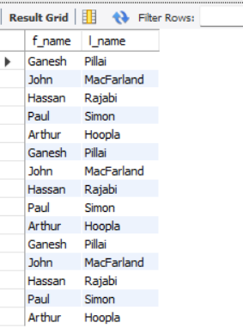
- List all employee names with salaries for employees who draw between $70000 and $90000.
SELECT f_name, l_name from employee_data WHERE title IN ('Senior Programmer', 'Multimedia Programmer');
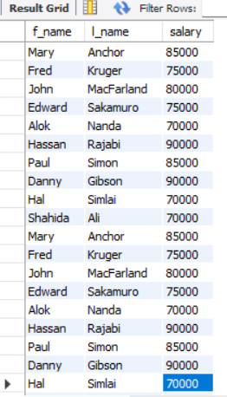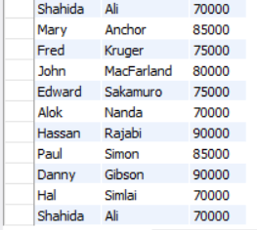
- What will the following statement display?
SELECT f_name, l_name, title from employee_data WHERE title NOT IN (‘Programmer’, ‘Senior Programmer’, ‘Multimedia Programmer’);
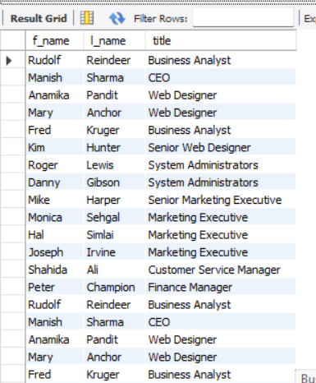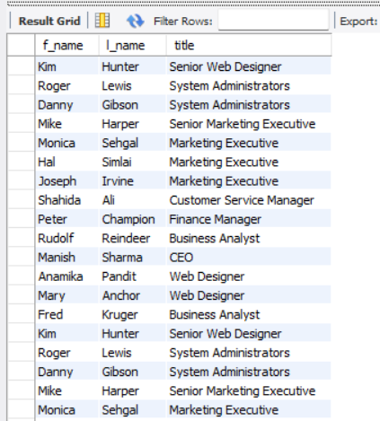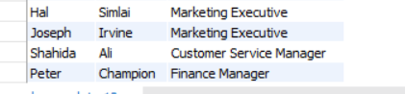
- Her is a more complex statement that combines both BETWEEN and IN. What will it display?
SELECT f_name, l_name, title, age from employee_data WHERE title NOT IN (‘Programmer’, ‘Senior Programmer’, ‘Multimedia Programmer’) AND age NOT BETWEEN 28 and 32;
